**Team Airbenders**

**Use cases**

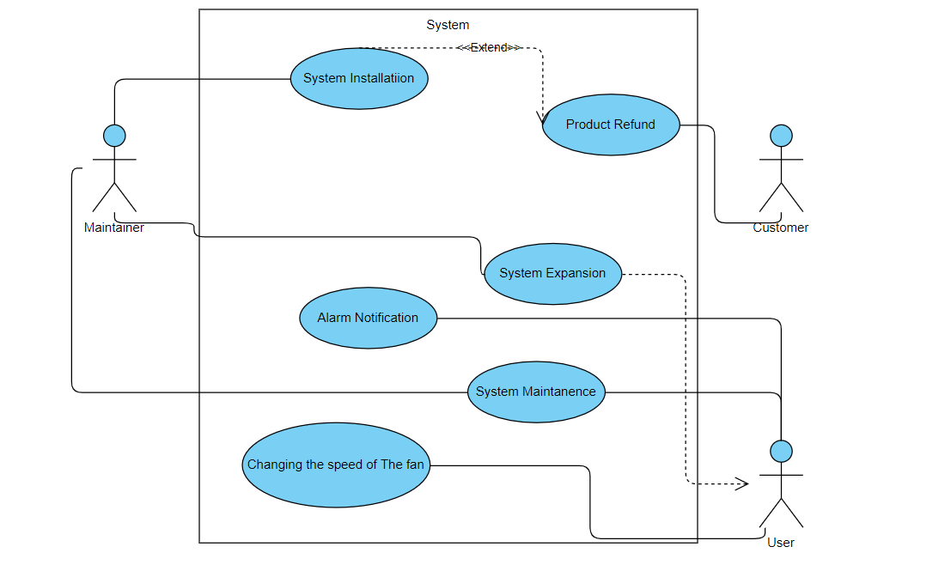

(please update)

|  |  |  |  |  |
| --- | --- | --- | --- | --- |
| **Use case ID** | **Must have** | **Should have** | **Nice to have** | **Not implement** |
| UC-01 | X |  |  |  |
| UC-02 | X |  |  |  |
| UC-03 | X |  |  |  |
| UC-04 | X |  |  |  |
| UC-05 | X |  |  |  |
| UC-06 | X |  |  |  |
| UC-07 | X |  |  |  |
| UC-08 | X |  |  |  |
| UC-09 | X |  |  |  |
| UC-10 | X |  |  |  |
| UC-11 | X |  |  |  |
| UC-12 | X |  |  |  |
| UC-13 | X |  |  |  |
| UC-14 | X |  |  |  |
| UC-15 | X |  |  |  |
| UC-16 | X |  |  |  |

(please update)

**ID:** UC-1

**Use case:** System installation

**Actor:** Maintainer

**Trigger:** System is ordered by customer

**Pre-condition:** System has been paid for by the customer

**Main success scenario:**

1. Maintainer visits customer’s address.
2. Sensors are installed in the locations specified by the customer.
3. Sensors are configured.
4. System functionality is tested.
5. Maintainer leaves the premise.

**Extensions:**

1a. 1. If address is not specified in order, call the customer for instructions.

2. End of use case.

1b. 1. If user prefers to be present during the installation, contact them for appropriate times.

2. End of use case.

2a. 1.If the customer has no specific locations in mind it is up to the maintainer to choose appropriate locations.

2. Continue to 3. from MSS

**ID:** UC-2

**Use case:** System expansion

**Actor:** Maintainer

**Trigger:** User requests expansion

**Pre-condition:** User already has a compatible system installed at home and has paid for an expansion

**Main success scenario:**

1. Maintainer visits customer’s address.
2. Additional sensors/ventilation box are/is installed on the premise.
3. Additional sensors/ventilation box are/is configured.
4. System functionality is tested.
5. Maintainer leaves the premise.

**Extensions:**

1a. 1. If address is not specified in order, call the customer for instructions.

2. End of use case.

1b. 1. If user prefers to be present during the installation, contact them for appropriate times.

2. End of use case.

2a. 1.If the customer has no specific locations in mind it is up to the maintainer to choose appropriate locations.

2. Continue to 3. from MSS

**ID:** UC-3

**Use case:** Product refund

**Actor**: Customer

**Main Success Scenario:**

1. Customer recognizes problem
2. Customer contacts customer support to report problem
3. Company reviews problem
4. Customer ships defect product for further examination
5. Company detects an error
6. Company offers replacement product
7. Customer accepts offer
8. Customer receives replacement product
9. Received product functions as expected

**Extensions:**

3a. Product problem needs further examination by company

1: Return to step 4

3b. Product problem is clear to company without thorough examination (well-known manufacturing problem in multiple devices)

1: Return to step 5

5a. Company detects problem caused by user

1: Customer is informed

2: End of use case

5b. Company detects problem caused by company (manufacturing or shipping problem)

1: Return to MSS step 5

6a. Customer refuses replacement product and wants a refund instead

1: Refund is declined

2: Return to MSS step 5 or end of use case

9a. Received product doesn’t function as expected

1: Refund the cost of the product

2: Company reviews the broken received product

3: End of use case

**ID:** UC-4

**Use case:** Alarm notification

**Actor:** User

**Pre-condition**: sensor readings too high

**Main Success Scenario:**

1. System detects extremely high value.
2. System notifies user.
3. System tries to handle the situation by itself.
4. Value is back to normal.
5. Alarm stops.

**Extensions:**

3a. System can’t handle situation

1: notify emergency services

2: End of use case

**ID:** UC-5

**Use case:** Changing the speed of the fan

**Actor:** User

**Trigger:** Increase or decrease the temperature

**Pre-condition:** User is dissatisfied with conditions

**Main success scenario:**

1. The user goes to fan settings in the application.
2. Enter the value of the temperature that he wants to set.
3. If the entered value is going to result in uncomfortable conditions according to the standards, the system will display a warning message on the screen.
4. User ignores the message and his/her preferred settings override the defaults.

**Extensions:**

4a 1. If user wants to use the advised value, he can click the message in 4.

2. End of use case.

**ID:** UC-6

**Use case:** System maintenance

**Actor:** Maintainer, user

**Trigger:** Issue in software or hardware

**Pre-condition:** The company is responsible for fixing issues either within the warranty period for free, or after this period if the issue is not related to the hardware.

**Main success scenario:**

1. The user follows the troubleshooting tips to figure out the issue.
2. User attempts everything described in the tips.
3. User contacts maintainer to report issue.
4. Maintainer handles the issue and tests the system.
5. Maintainer asks the user for feedback on the process.

**Extensions:**

2a 1. User fixes the issue by themselves.

2. End of use case.

3a 1. If the issue related to the software sector, the support team will attempt to solve the issue remotely.

2. continue to 4.

**ID:** UC-7

**Use case:** VOC sensor failure

**Actor:** VOC sensor, Maintainer, User

**Trigger:** VOC sensor stops sending data

**Pre-condition:** VOC sensor installed in the system

**Main success scenario:**

1. Installation box stops showing VOC values.
2. User attempts to fix issue by themselves (see UC-5).
3. User contacts maintainer.
4. Maintainer tests the sensor with another shield/hardware.
5. A new sensor is installed.
6. The new sensor is calibrated.
7. The new sensor is tested.

**Extensions:**

2a. 1. User manages to fix issue by themselves.

2. End of use case.

4a. 1. Sensors works with another shield/hardware.

2. Issue is not with VOC sensor.

3. End of use case.

**ID:** UC-8

**Use case:** VOC sensor sends value

**Actor:** VOC sensor

**Trigger:** 15 minutes have elapsed since last send

**Pre-condition:** Sensor is connected to ventilation box

**Main success scenario:**

1. VOC sensor takes volatile organic compound reading.
2. Value is parsed according to protocol standards.
3. Value is sent to ventilation box via WiFi.
4. Value is read by ventilation box.

**Extensions:**

1a. 1. Sensor is unable to take accurate reading.

2. See UC-6.

3. End of use case.

**ID:** UC-9

**Use case:** ZigBee module disconnects

**Actor:** Maintainer, ZigBee

**Trigger:** Ventilation box detects traffic loss

**Pre-condition:** System has not been manually turned off by user

**Main success scenario:**

1. User is notified of the traffic loss.
2. User attempts to reconnect it manually.
3. User contacts maintainer.
4. Maintainer fixes the issue.

**Extensions:**

1a. 1. User is not notified of the traffic loss.

2. Go to 3. from MSS.

2a. 1. User manages to reconnect it by themselves.

2. End of use case.

4a. 1. ZigBee module is defect.

2. Maintainer replaces module.

3. End of use case.

**ID:** UC-10

**Use case:** System connects with ventilation box

**Actor:** ZigBee, Maintainer, Ventilation box

**Trigger:** Maintainer is installing the system

**Pre-condition:** Ventilation box has been installed and configured

**Main success scenario:**

1. SSID of the network is entered.
2. Password of the network is entered.
3. Sensors and ventilation box connect.
4. A successful connection message appears.

**Extensions:**

1a. 1. Wrong IP address is entered.

2. Prompt saying such IP does not exist appears on screen.

3. Repeat 1. from MSS.

2a. 1. Wrong password is entered.

2. Prompt saying the password is wrong appears on the screen.

3. Repeat 2. from MSS.

3a. 1. Connection is not established.

2. Go to 1. from MSS.

3b 1. Connection is not established multiple times.

2. See UC-7.

3. End of use case.

**ID:** UC-11

**Use case:** Temperature & humidity sensor sends values to ventilation box

**Actor:** ZigBee, Temperature & humidity sensor

**Trigger:** 15 minutes have elapsed since last send

**Pre-condition:** Sensors is working properly

**Main success scenario:**

1. Sensors measures temperature and humidity values.
2. Value is parsed according to protocol standards.
3. Value is sent to ventilation box via WiFi.
4. Value is read by ventilation box.

**Extensions:**

1a. 1. Sensor is unable to take accurate reading.

2. See UC-6.

3. End of use case.

**ID:** UC-12

**Use case:** Temperature & humidity sensor stops working

**Actor:** Temperature & humidity sensor, ZigBee , maintainer

**Trigger:** The sensor does not send new value.

**Pre-condition:** Sensor is connected to ventilation box

**Main success scenario:**

1. Ventilation box stop showing the value that should receive from the sensor.
2. The system restart itself after period of time if the issue remains.
3. The user contact with maintainer.
4. The maintainer test the system again.
5. Specifying the problem.
6. The maintainer install a new sensor.

**Extensions:**

2a 1. If the system after restarting itself return back working.

2. End of use case.

4a 1. If there are any other issues.

2. fix/install the inactive component

3. end of use case

**ID:** UC-13

**Use case:** Ventilation box reads data.

**Actor:** Ventilation box, sensors

**Trigger:** The Ventilation box receive data from the sensors.

**Pre-condition:** ventilation box is installed.

**Main success scenario:**

1. Ventilation box receive parsed data from the sensor
2. Use protocol to read the data
3. Transform the data to information
4. Show the information on the screen
5. Update the information every time a new data is received

**Extensions:**

1a 1. Ventilation box does not receive data

2. show a warning message.

3. see UC-7

4. End of use case.

**ID:** UC-14

**Use case:** Ventilation box displays error message

**Actor:** Temperature & humidity sensor, ZigBee , Ventilation box, maintainer

**Trigger:** issue in one of the sensors or network disconnected

**Pre-condition:** all sensors and Ventilation box are installed, the network is connected

**Main success scenario:**

1. The sensors send value in wrong format
2. OR The network is disconnected
3. OR The sensors does not work
4. The system restart itself if the issue still remain.
5. The user contact with maintainer.
6. Specifying the problem
7. Fixing the problem.

**Extensions:**

4a 1. If the system after restarting itself return back working.

2. End of use case.

**ID:** UC-15

**Use case:** Another hardware package is connected

**Actor:** New hardware, Ventilation box

**Trigger:** the system discover a new hardware is installed

**Pre-condition:** The system has a portability to identify a new hardware

**Main success scenario:**

1. Show a notification that there is a new hardware
2. Identify the new hardware
3. Receive data from the new hardware
4. Use the protocol to transform the data to value
5. The new hardware works like the old one

**Extensions:**

3a 1. Does receive a data

2. go to 2. To make sur that the new hardware is identified

3. end of use case.

4a 1. The protocol is not able to transform the data to value.

2. change the protocol to be compatible with the new hardware.

3. end of use case.

**ID:** UC-16

**Use case:** Another ventilation box is connected

**Actor:** The new Ventilation box, sensors

**Trigger:** the system discover another ventilation box

**Pre-condition:** The system has a portability to identify another ventilation box

**Main success scenario:**

1. Show a notification that there is another ventilation box
2. The new ventilation box identify all sensors
3. The new ventilation box connect to the network
4. Sensors send a data to both ventilation box
5. The new ventilation box use its own protocol.
6. Both ventilation box works properly.

**Extensions:**

(please update)